Interactive Augmented Reality with Meta 2

Kari Pulli, Charles Niu and Paulo Jansen, Meta Co.

Abstract:

Optical See-Through Augmented Reality, as supported by devices like Meta 2, Hololens, etc., provides a new medium. In this tutorial we will introduce the benefits of optical see-through AR over video see-through AR, which you could get by adding a video camera to a VR headset. We will also discuss the benefits over wearable AR over cellphone-powered AR, such as that your hands are free and are available as natural input devices, and that the AR graphics is directly registered with your vision. We will demonstrate various AR applications, and we will show how you can create your own using Meta SDK.

Bio:

**Kari Pulli** is CTO at Meta. Before joining Meta, Kari worked as CTO of the Imaging and Camera Technologies Group at Intel influencing the architecture of future IPUs. He was VP of Computational Imaging at Light and before that he led research teams at NVIDIA Research (Senior Director) and at Nokia Research (Nokia Fellow) on Computational Photography, Computer Vision, and Augmented Reality. He headed Nokia's graphics technology, and contributed to many Khronos and JCP mobile graphics and media standards, and wrote a book on mobile 3D graphics. Kari holds CS degrees from University of Minnesota (BSc), University of Oulu (MSc, Lic. Tech.), University of Washington (PhD); and an MBA from University of Oulu. He has taught and worked as a researcher at Stanford University, University of Oulu, and MIT.

**Charles Niu** is a developer at Meta, and has worked on numerous prototyping and demo projects. He worked as a lead for Meta's showcase at Sundance 2017, and has had his work showcased at numerous expos. He first picked up AR/VR development at UC Berkeley where he was an active member of the VR community there. At Meta, Charles actively explores novel approaches to HCI design to improve user experience.

**Paulo Jansen** is a SW Engineer at Meta, working on interactive augmented reality applications for the Meta AR headset. He has a MSc in Computer Science with emphasis in Image Processing applied to VR and AR from UFMA (Brazil), where he worked as a research assistant. Paulo's professional interests include Computer Graphics, Image Processing, and VR / AR interactive applications.

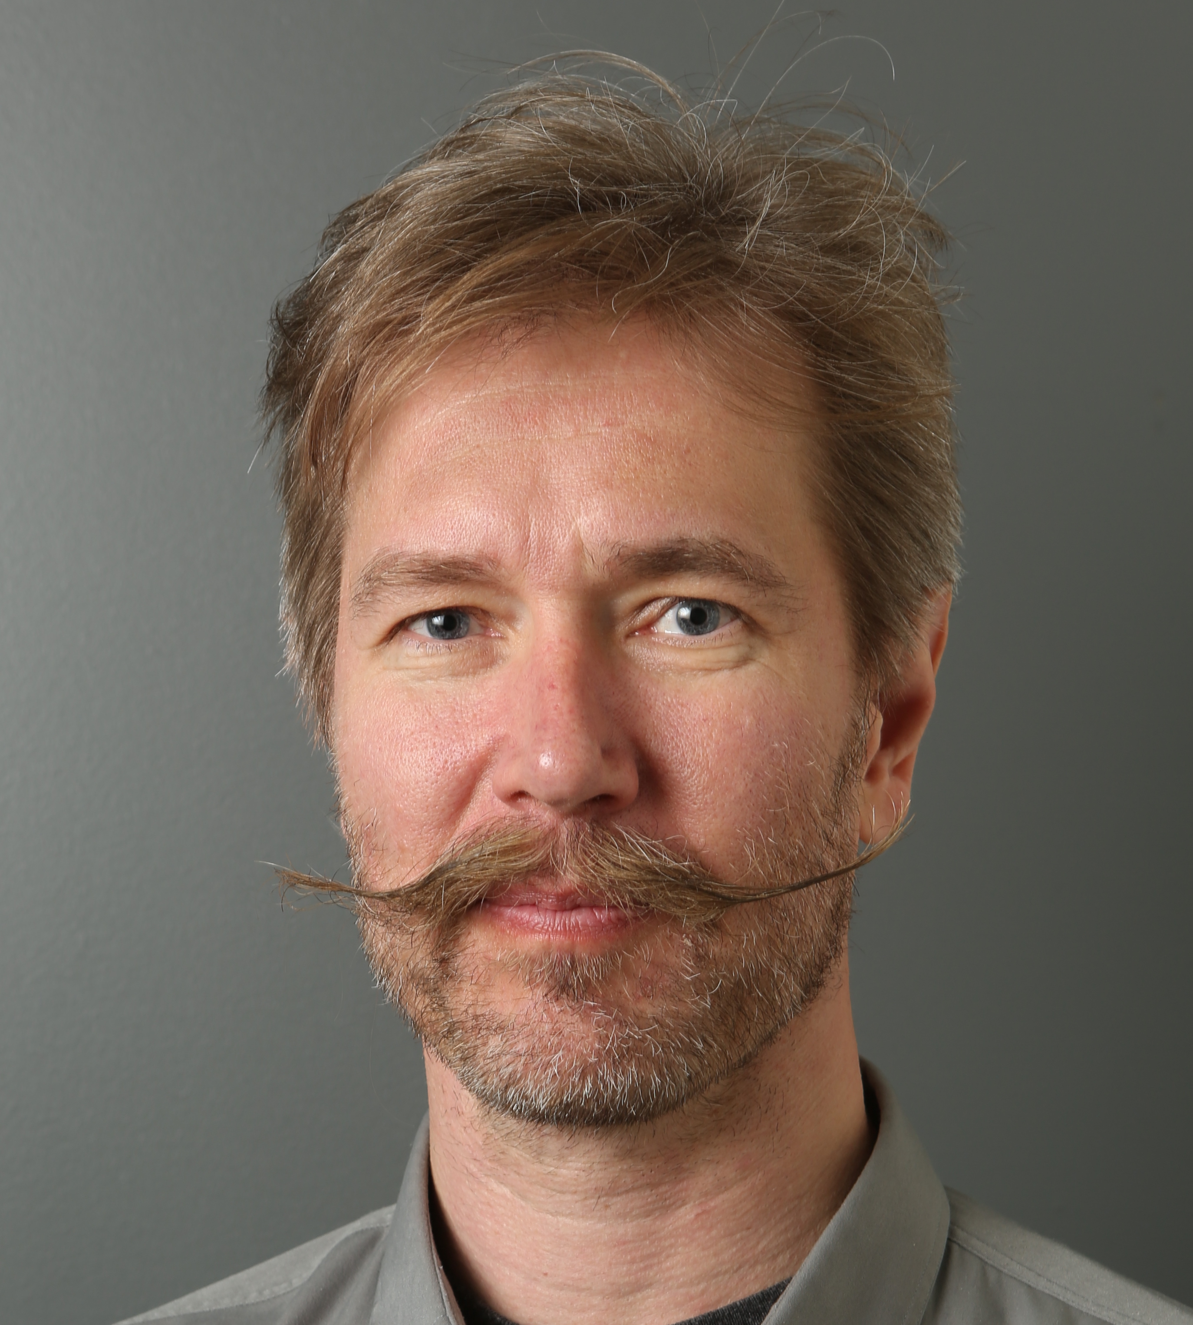

Kari Pulli



Charles Niu

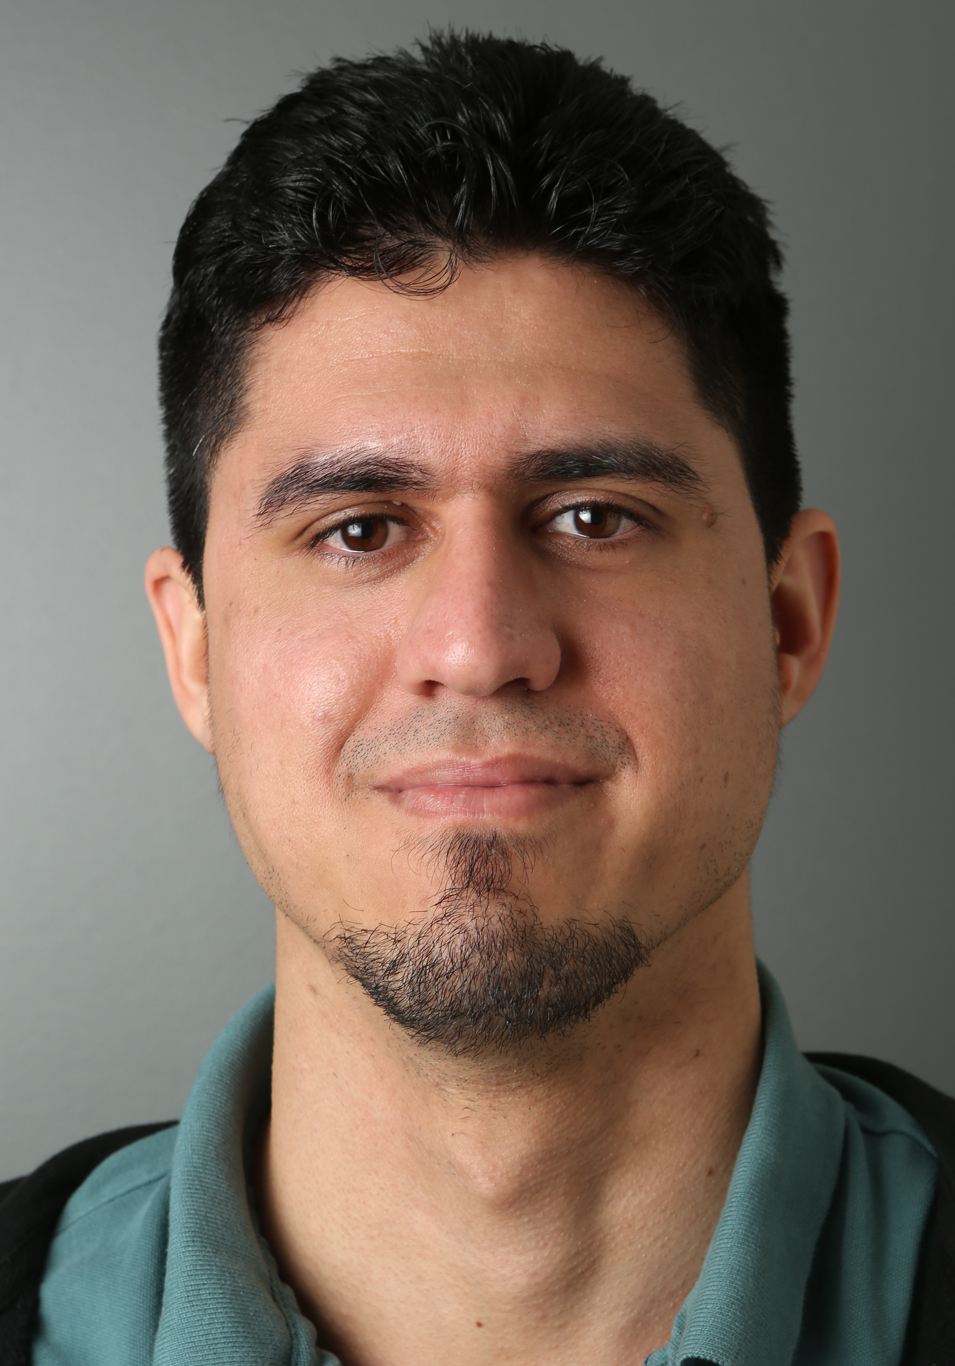

Paulo Jansen